Table of contents

1.0 My company

**GreyMatter**

GreyMatter : Vision and Mission

To provide the world with better and cheaper alternative IT solutions,

1.1 Introduction

GreyMatter is an IT solutions company headquartered in Kuala Lumpur, Malaysia.

Problems

There are several problems that can be associated with the current system. Firstly, the card system for borrowing books is suboptimal as having to deal with 4 cards can be a hassle.

Furthermore, the physical records such as registration forms, consume a lot of physical space for storage as a result bringing the efficiency of the management down.This happens due to the increasing number of records needing storage space and apart from that, it is less cost-effective. The combined effect of all these issues negatively affects the organization and its management. In addition to that, the chances of loss and damage to the records is high which are mostly caused by human error since the records are in physical form and have to be handled manually which makes them susceptible to those vulnerabilities.

Proposed solution

My target is the development of a system that enables time reduction on manual activities like the transactions of books and managing records. Furthermore, my company would make use of a process that keeps the book records safe by getting rid of the physical storage and paper forms, and using the computerized system making the access user-friendly at the same time eliminating any chance of human error. This in turn will provide better service for the users as a result increasing their satisfaction.In addition, carrying four cards around for the purpose of borrowing books is a hassle, therefore my company proposes one card that would be connected to a database that would present the record related to that card and that user, because each user will have a unique card and card id. Once getting access to the record the staff will be able to see how many books has the user borrowed already and how many is the user able to borrow at that time. Moreover, the system will be a lot more cost-efficient and minimize any unnecessary errors ,which were previously being caused by manual system management, and speeding up the process of search and material management in the library for the staff, employees, and users. Lastly, if the storage is computerized, the risk of a fire or water damage to the records will also be significantly cut down.

**Project Planning**

System Development Life Cycle (SDLC)

The System Development Life cycle (SDLC) also known as System Development Process, is a systematic process for planning and building of a system that ensures the quality and correctness of the built system. Through SDLC we aim to produce a high-quality system which meets the clients expectations and fulfills our own quota of quality. SDLC consists of a detailed plan which explains how to plan, build, and maintain specific systems. Every phase of the SDLC life cycle has its own process and deliverables that feed into the next phase. The development of the system will be completed in the pre-defined time frame and cost.

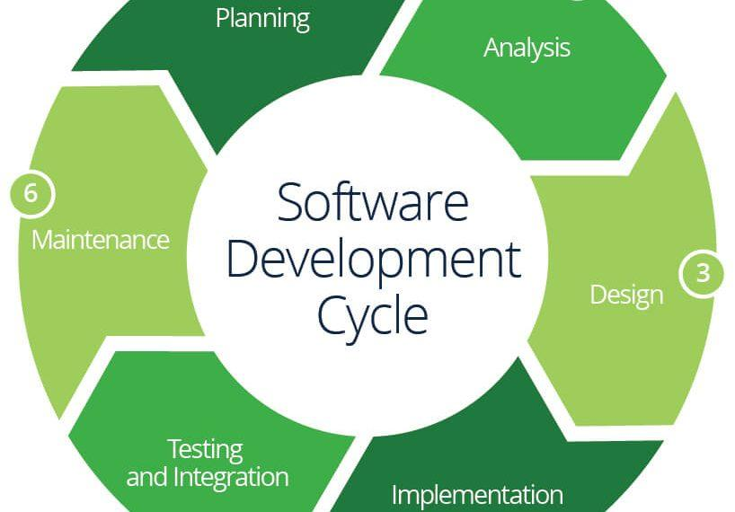

## 

## 

## 

## Feasibility Study

A feasibility study is an analysis that takes all of a project's relevant factors into account including economic, technical, legal, and scheduling considerations to ascertain the likelihood of completing the project successfully. Project managers use feasibility studies to discern the pros and cons of undertaking a project before they invest a lot of time and money into it.

Technical Feasibility

A technical feasibility study is an excellent tool for both troubleshooting and long-term planning. It can serve as a flowchart of how your products and services evolve and move through your business to physically reach your market.

**• Is the proposed technology or solution practical?**

Yes it is practical and much needed.With the current state of the system and the rate at which it is growing,will soon require the management to rent out spaces just for storage.Therefore the solution that my company is proposing will greatly reduce costs and provide for a much better user experience for staff and students.It is a fully computerized system that works with the transactions of borrowing, returning and searching of members and books that are in the library. This new proposed library management system is used to avoid the worn out system in use previously.

• **Do we currently possess the necessary technology?**

The current manual system of the library is not scalable or upgrable as it does not have any of the necessary technologies or any technology at all as it is entirely manual and paper-based.Therefore a totally new and improved system must replace which requires acquiring the technology needed to do that.

**• Do we possess the necessary technical expertise, and is the schedule reasonable?**

Yes Framework does possess the necessary technical expertise that will be used to help the library management system to improve and meet the organizational goals and user’s satisfaction. As for the teams’ schedule, it has been organized in a manner that would help to complete the project smoothly and effectively within the time provided in the schedule.

**• If the technology is not available, can it be acquired?**

Based on the requirements and the deliverables laid out,certainly some level of modern-day technologies will be needed for better performance to the online book transaction and record saving as currently there is none of that.

Operational feasibility

Operational feasibility refers to the measure of solving problems with the help of a new proposed system. It helps in taking advantage of the opportunities and fulfills the requirements as identified during the development of the project. It takes care that the management and the users support the project.PIECES framework contained in operational feasibility is a form that breaks down the key essentials in any project and helps to pinpoint the steps and stages in the process and the maintenance of the project

**Performance**: Does the current mode of operation provide adequate throughput and response time?

In performance, throughput is the rate of which the project is being processed. Response time is the delayed time between requests and transactions and getting a response to those requests and transactions. The current manual system in Pioneer library is poor and deficient due in terms of the delays it causes in transactions of books and other tasks. The proposed system for the management will have the ability to store all of the books records and store the history of the borrowed and currently borrowed books electronically. Also, the system will be able to retrieve the records of the users and library employees, send emails to library users confirming their borrowing and reminding them of the borrowing deadline, and retrieve user information if needed

**Information:** Does the current mode provide end users and managers with timely, pertinent, accurate and usefully formatted information?

Information identifies if the proposed system can provide the appropriate amount of detail and accuracy of data to the end users and managers. Since the current system is manual and paper based, it means that when a user borrows a book the employee has to confirm the borrowing transaction on paper, in this case, the user will not have any data about the borrowing details. There is also a high possibility for human errors to happen from both users and employee about the different details of the borrowing and/or returning transaction. Another obstacle arises when a user wants to go through the library’s catalog to find the desired book.This manual process is time-consuming and inefficient as it would take so much more time to do this while a computerized catalog would instantly allow him or her to find the desired book and whether or not it is available.Hence avoiding redundancies.

**Economy:** Does the current mode of operation provide cost-effective information services to the business?

Could there be a reduction in costs and or an increase in benefits? The proposed system will certainly be beneficial in terms of cost.Although there are not any upfront benefits,but there are several cost avoidance benefits.Such as no further need of buying paper and pens for the record, lesser number of staff members and an overall increase in customer satisfaction which would result in frequent visits by customers and cause an increase in popularity and be a source of free marketing.

**Control:** Does current mode of operation offer effective controls to protect against fraud and to guarantee accuracy and security of data and information?

Control in the PIECES framework identifies if the managing techniques used in the proposed system guarantee security against spam and keeps information and data safe. With the use of the computerized system, no one can access the database except authorized people like employees and company users by using the log in function to keep all the members details safe.

**Efficiency:** Does the current mode of operation make maximum use of available resources, including people, time, flow of forms?

Efficiency is how the proposed system makes use of the available resources, time, flow of work, members data, transactions, activities and cost. All of the company’s resources should be used in an efficient way in order to achieve the desired output and results without wasting money and time.With the proposed system, efficiency is the biggest advantage.

**Services:** Does the current mode of operation provide reliable service? Is it flexible and expandable?

This is a question of whether or not the proposed system will be able to provide reliable services and dependable outputs. In comparison to the old system, this system would be very reliable and it is expandable.Depending on the future requirement improvements to the existing system can be easily made.

Schedule feasibility

It is defined as the probability of a project to be completed within its scheduled time limits, by a planned due date. If a project has a high probability to be completed on-time, then its schedule feasibility is appraised as high. In many cases a project will be unsuccessful if it takes longer than it was estimated.

Economic feasibility

Economic feasibility is a cost-benefit analysis of the project, which assesses whether it is possible to implement it. Moreover, it means the assessment and analysis of a project's potential to support the decision-makingprocess by objectively and rationally identifying its strengths, weaknesses, opportunities and risks associated with it, the resources that will be needed to implement the project, and an assessment of its chances of success.

**Cost / benefit Classifications**

• Tangible / Intangible costs Tangible cost is a cost that can specifically be assigned, like salary, hardware purchase. Intangible cost is a cost that the value cannot be calculated exactly, like user’s satisfaction.

**• Direct / Indirect costs**

Direct cost is the cost that is directly associated with the development of the new system, like purchase of hardware. Indirect cost is the cost that cannot be specified in the developing of a new system, like insurance expenses and machine rental.

**• Fixed / Variable costs**

Fixed cost is a cost that is always constant and does not depend on anything, like salary. Variable cost is a cost that changes depending on the level of activity, like printing paper and supplies.

**• Developmental costs**

Development cost is a cost that only occurs one time in the developing of a new system, like development, hardware and software purchase.

## 

## System Design

ERD

Entity Relationship Diagram, also known as ERD, ER Diagram or ER model, is a type of structural diagram for use in database design. An ERD contains different symbols and connectors that visualize two important information: The major entities within the system scope, and the inter-relationships among these entities.

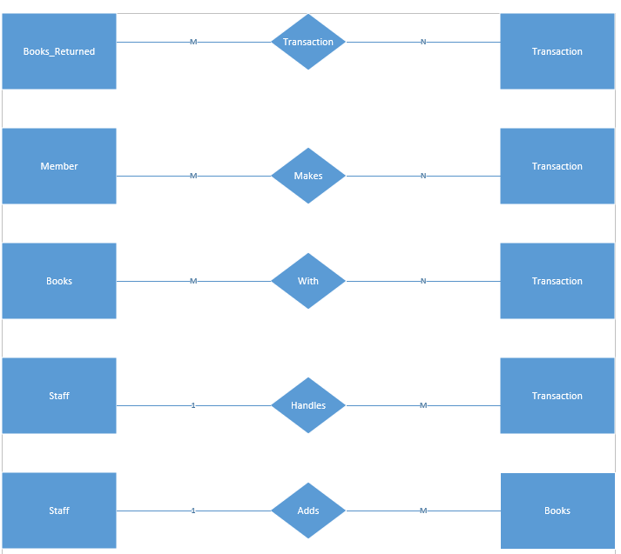

The ERD of the new system explains how the system will carry out the data managing and information storing for the library. There are five entities in the new system, Members, Staff, Books, Transaction, and Books returned. The relationships between the entities to control the flow and manage the system are as follows. One member can borrow one or more books at a time, and return one or more books at a time, which means a member can have more than one transaction at one go but a transaction can only belong to one member. In transactions, there is more than one returned book transaction and borrowed books transactions, however, a book can have only one transaction at a time. Lastly, one staff can be responsible for more than one transaction, but a transaction can be conducted only by one staff. Also, a staff can add more than one book to the system, but a book can be added by one staff only.

Context Diagram:

A context diagram shows the system under consideration as a single high-level process and then shows the relationship that the system has with other external entities such as the systems,organizational groups,external data stores etc.

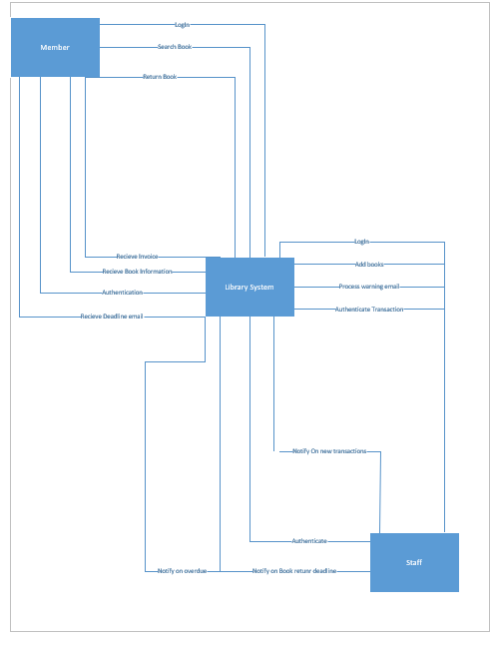

## Sampling

A. Technique being used

For the purpose of Information gathering, the sampling method will be used, and to be more specific, the sampling technique that will be used is called Stratified Sampling. Stratified sampling involves dividing the population into smaller groups ,in this case the population under consideration are the stakeholders of the library, which include the students and staff members. In this method, the users of the library will be classified into groups and for each group, a certain portion will be selected for sampling. Each of the members of the groups will have certain attributes in common such as their level of education, for example diploma students would be classified into one strata, the working staff in the library will be made into another group and so on. This will ensure participation of all the different classes of education including the staff who are also stakeholders of the system.

**The pros**

This method is very effective because the results that you get are very realistic and accurate. The reason for that is that in the case of a library, the only real difference that we are concerned with amongst users is their level of education. And with this method we are able to take that Into account. Moreover, our results are unbiased since every concerned attribute is being represented and is part of the survey.

**The cons**

One disadvantage of this method is the overlapping of strata or the groups that have been classified. It is possible that one person could fall under two different strata, such as a master's degree student working in the library. Another disadvantage is the that this is a time taking method, as all participants have to to be classified into groups and surveyed. Lastly, another disadvantage of this method is that not all users of the system will be able to participate and Influence the results of the survey as only a portion of each strata will be taken into consideration.

B. How the investigation will be carried out

The investigation will be carried out in four steps.

**Step 1: Determining the data to be collected**

The first thing to be done is the narrowing down on the purpose of investigation to ensure no irrelevant or unusable data is collected as that would be a waste of effort, money and time. And in order to do this correctly, there are certain factors we will consider such as identifying the variables, attributes and associated data items that are concerned with the sampling process.

**Step 2: Determine the population to be sampled**

Now we have to determine the population under consideration ,in this case it is the users of the library. Moreover, when it comes to hard data we also have to decide on the time frame, that is determining how many reports are sufficient enough for the sampling, whether it is two months of data or four months of data etc. In addition to that we may also consider including people out of the system such as people using other systems that have the same function, such as other libraries.

**Step 3:Choosing the type of sample**

This is the most important part of the sampling process, and there are several ways that we could go about conducting the process, for example convenience sampling and complex sampling. Convenience samples are unrestricted, nonprobability samples. A sample could be called a convenience sample if, for example, the systems analyst posts a notice on the company’s intranet asking for everyone interested in working with the new sales performance reports to come to a meeting at 1 P.M. on Tuesday the 12th. Obviously, this sample is the easiest to arrange, but it is also the most unreliable. On the other hand, complex sampling methods, have several types too,such as systematic sampling, cluster sampling and stratified sampling.In the simplest method of probability sampling and systematic sampling, the systems analyst would, for example, choose to interview every nth person on a list of company employees. Although this method has certain disadvantages. You would not want to use it to select every kth day for a sample because of the potential periodicity problem. In addition to that, a systems analyst would not use this approach if the list were ordered for instance, a list of banks from the smallest to the largest), because that would be biased.

Stratified samples are the most appropriate in this scenario. Stratification is the process of identifying subpopulations, or strata, and then selecting objects or people for sampling in these subpopulations. Stratification is often essential if the systems analyst is to gather data efficiently. For example, if you want to seek opinions from a wide range of employees on different levels of the organization. A stratified sample would compensate for this. Stratification is also called for when the systems analyst wants to use different methods to collect data from different subgroups. For example, you may want to use a survey to gather data from middle managers, but you might prefer to use personal interviews to gather similar data from executives. Sometimes the systems analyst must select a group of people or documents to study. This process is referred to as cluster sampling.

**Step 4: Deciding on the sample size**

Now certainly, if everyone in the population had the same perception of the world and the situation the same way or if each of the documents in a population translated to the exact same information as every other document, a sample size of one would be sufficient. However, that is not the case, which is why it is necessary to set a sample size greater than one but less than the size of the population itself.

References